# Model

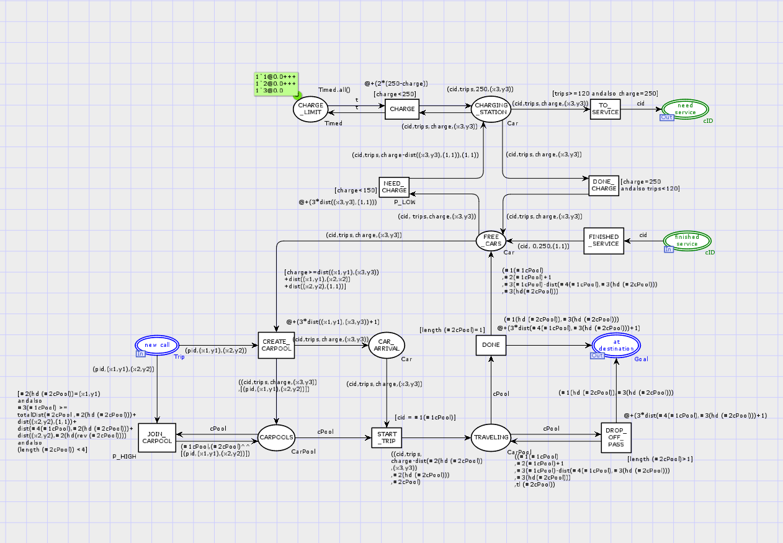

# Model Description

* After a car completed service in the garage, its car id is available in place (finished service). From there it takes transition FINISHED_SERVICE to place FREE_CARS. FINISHED_SERVICE adds the cid to its corresponding car with full charge and 0 trips and position (1,1).
* From FREE_CARS the car can either go to the charging station and recharge or it can be used to create a new CarPool and start driving to pick it up.
* If the Car has less than 150 charge it can go to the CHARGING_STATION. If it does, its’ charge is updated properly. The charging station can charge up to 3 Cars at once. Once a Car has been fully charged, the Car can go back to the FREE_CARS place, or, if it has taken more than 120 trips since the last service, it will go to the need service place.
* When a new CarPool is created it takes a free Car and a Trip. The Trip and the Car are added to the CarPool and the CarPool goes to the CARPOOLS place.
* From the CARPOOLS place two things can happen. One, a new Trip with that same initial position can be added to the CarPool. Two, the corresponding Car can arrive, picking up the Trips, and the CarPool leaves the place. If the CarPool leaves CARPOOLS, its Cars’ charge and number of trips are updating respectively.
* Once the CarPool leaves the place, the Trips are dropped off at their destinations (using DROP_OFF_PASS) until no Trips are left in the CarPool. At this point the CarPool dissolves (with transition DONE) and its Car goes back to the FREE_CARS place. The Cars’ charge and number of trips are updated respectively during this process.
* Cars can only be added to the CarPools and Trips can only be added to exisiting CarPools if the corresponding charge is sufficient for the car to finish the entire task and still drive back to the charging station.

# Declarations, Guards, Arc Inscriptions, Functions

## Declarations

|  |  |
| --- | --- |
| trip1 | A Variable of type Trip |
| cPool | A variable of type cPool |
| tList | A variable of type TripList |
| TripList | A list of trips representing the passangers in a car pool |
| t | A variable of type Timed |
| X3,y3 | Variables of type INT |
| Timed | A timed integer used to limit charging to 3 cars at a time |
| Car | a collection of information representing a car. A Car contains a cid, an integer representing the amount of trips since the last service, an integer representing the remaining charge, and a location representing the cars current location |
| CarPool | A collection of variables representing a car pool. A CarPool contains the list of Trips in the pool and the Car that will pick them up |
| fun totalDist(nil,_) = 0 |  totalDist(((trip1:Trip)::tList),s) = dist(s,#3trip1)+totalDist(tList,s) ; | A function used to determine the total distance from s to the destinations of all passangers in TripList tList in order. |

## Guards and Arc Inscriptions

|  |  |  |
| --- | --- | --- |
| Guard/Arc Inscription | Where is it in the model? | Explanation |
| [#2(hd (#2cPool))=(x1,y1)  andalso  #3(#1cPool) >=  totalDist(#2cPool ,#2(hd (#2cPool)))+  dist((x2,y2),(1,1))+  dist(#4(#1cPool),#2(hd (#2cPool)))+  dist((x2,y2),#2(hd(rev (#2cPool))))  andalso  (length (#2cPool)) <4] | This is a guard for the JOIN_CARPOOL transition | This guard checks 3 things. First that the new Trip has the same starting position as the other Trips in CarPool. Second, that the corresponding Car has enough charge to pick up the new Trip. Third that the carpool has enough space left |
| (#1cPool,(#2cPool)^^  [(pid,(x1,y1),(x2,y2))]) | This is the Arc inscription between JOIN_CARPOOL and CARPOOLS | This adds the new Trip to the corresponding CarPool |
| ((cid,trips,  charge-dist(#2(hd (#2cPool))  ,(x3,y3))  ,#2(hd (#2cPool)))  ,#2cPool) | This is the Arc inscription between START_TRIP and TRAVELING | This moved the Car in the CarPool to the pickup location and adjusts charge appropriately |
| ((#1(#1cPool)  ,#2(#1cPool)+1  ,#3(#1cPool)-dist(#4(#1cPool),#3(hd (#2cPool)))  ,#3(hd(#2cPool)))  ,tl (#2cPool)) | This is the Arc inscription between TRAVELING and DROP_OFF_PASS | This moved the car to the destination where it just dropped of a Trip and adjusts charge and number of trips appropriately |
| (#1(#1cPool)  ,#2(#1cPool)+1  ,#3(#1cPool)-dist(#4(#1cPool),#3(hd (#2cPool)))  ,#3(hd(#2cPool))) | This is the Arc inscription between DONE and FREE_CARS | This does the same thing as the Arc inscription between TRAVELING and DROP_OFF_PASS except it represents the last Trip in the carpool so it is a Car colorset instead of a CarPool colorset |

# Simulation Results

## Summary of Simulation Results

From the simulation report it can be seen that my model always completes 1000 trips successfully with on average only 120 trips taking too long.

## Raw Simulation Reports

